

Capstone Project Report
Report 4 – Software Design Document

– Ho Chi Minh, October 2026 –

Table of Contents
I. Record of Changes 3
II. Software Design Document 4
1. System Design 4
1.1 System Architecture 4
1.2 Package Diagram 5
2. Database Design 7
3. Detailed Design 10
3.1 Mission Planning and Approval 10
3.2 Realtime Monitoring and Incident Management 16
3.3 Post-flight History and Reporting 19
3.4 AI-assisted Mission Assessment 21
3.5 Automatic Flight Execution 23
Scope and operating boundary 23
End to end operation 23
Dispatch authorization 23
Exceptions and pilot authority 23
Backend and portal responsibilities 23
Gateway and adapter responsibilities 24
Execution envelope and persistence 24
Automation state and mission lifecycle 24
Transaction and failure boundaries 24
Interfaces and synchronization 24
Protocol and profile references 24

I. Record of Changes
Date | A*  M, D | In charge | Change Description
20/10/26 | A | Project team | Prepared DroneOps Intelligence Software Design Document for Review 2.
*A - Added M - Modified D - Deleted

II. Software Design Document

1. System Design

1.1 System Architecture
DroneOps Intelligence uses a Next.js/React Web application, an ASP.NET Core API, application services, EF Core/Npgsql persistence and PostgreSQL. A telemetry gateway supplies normalized MAVLink-derived samples, and SSE delivers authorized live updates. Backend adapters provide media storage, email and AI integration. Low-level UAV flight control remains external.
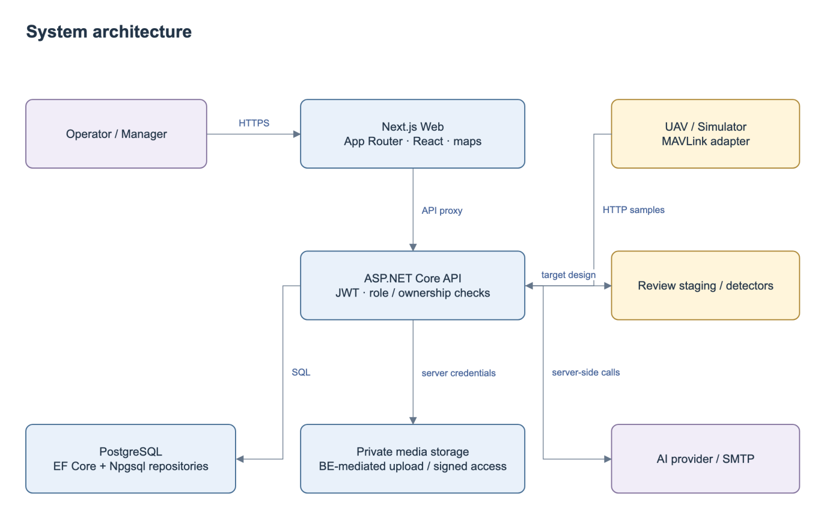
Figure 1. System Architecture.
No | Component | Description
1 | Next.js Web + proxy | Role-specific pages, client validation, map, same-origin forwarding. Backend remains authoritative for authorization and state.
2 | API + Application | JWT/canonical roles, DTO validation, business services and outcome errors. Controllers delegate business operations to services; the composition root configures persistence and external adapters.
3 | Persistence + Domain | EF entities/repositories plus Npgsql stores. Application depends on repository interfaces in Persistence and entities in Domain.
4 | PostgreSQL / media | Transactional domain records; proposed request/evidence storage. Private user media uses protected backend read/upload and short-lived access; no public server secret.
5 | Integration gateway / SSE | The trusted Python MAVLink gateway provides controller enrollment, mission upload/read-back, authenticated execution envelopes and telemetry; an independent loss timer, authorized snapshots and SSE support monitoring.
6 | External AI / email | Configured outbound calls with bounded timeout, provenance and error handling. AI advice cannot approve missions.

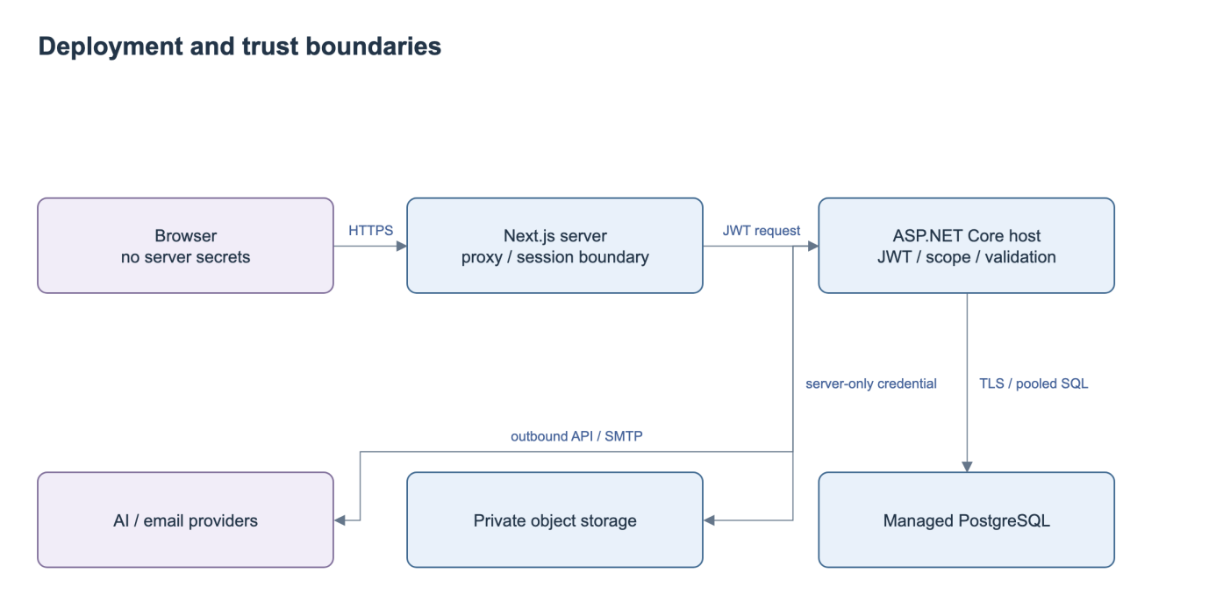
Figure 2. Deployment and Trust Boundaries.

1.2 Package Diagram
The backend packages separate API endpoints, application services, persistence and domain entities. The Web subsystem groups route components, shared clients and API forwarding.
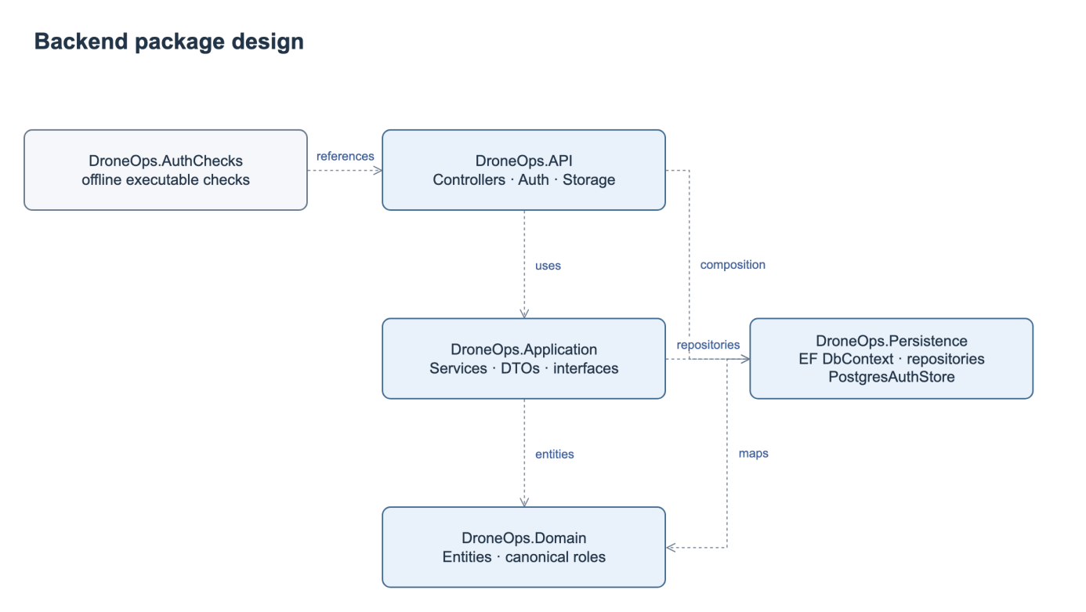
Figure 3. Backend Package Diagram.
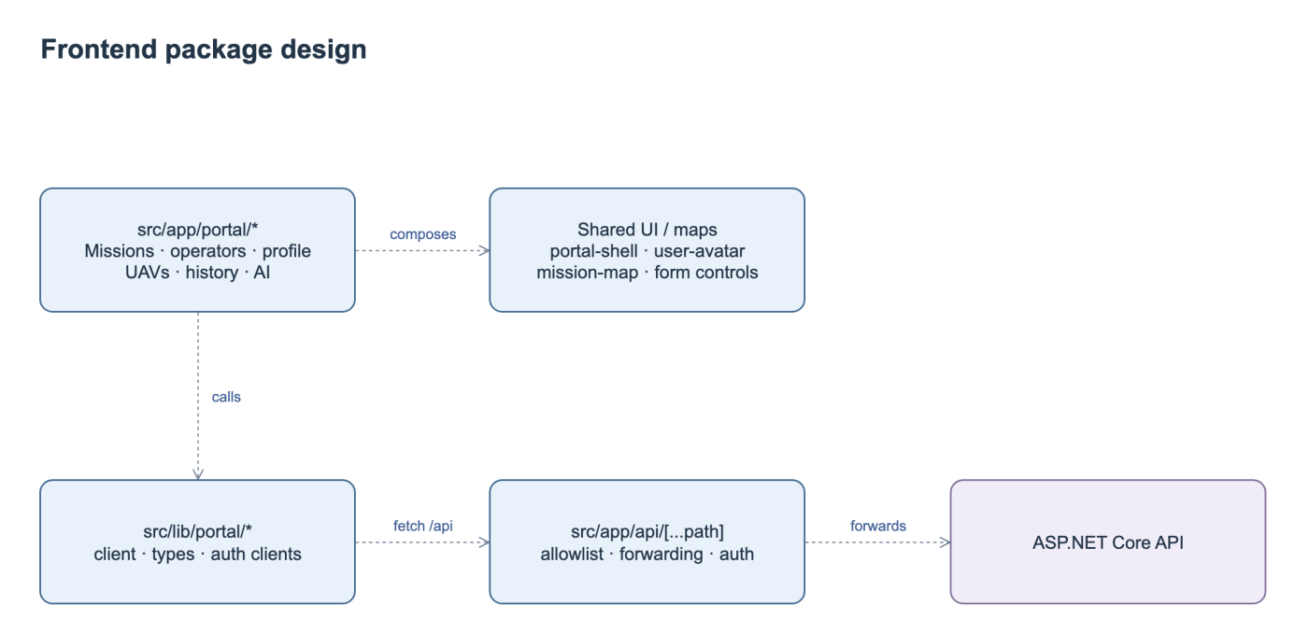
Figure 4. Web Package Diagram.
Package Descriptions
No | Package | Description
1 | DroneOps.API | Controllers/{Missions,Integrations,Incidents,Users,PostFlight}; authentication middleware, Storage helpers, composition root.
2 | DroneOps.Application | Services/{Missions,Telemetry,Incidents,PostFlight,AI,Auth}; request/response DTOs and service interfaces.
3 | DroneOps.Persistence | AppDbContext, repositories and interfaces; PostgresAuthStore; Npgsql pooling.
4 | DroneOps.Domain | Mission, Waypoint, UAV, User/Pilot, TelemetryRecord, Incident, MissionApproval, PostFlightReport and related records.
5 | DroneOps.AuthChecks | Executable offline authorization/validation checks; not a full database or end-to-end test suite.
6 | fe/src/app/portal | Mission/UAV/operator/profile/geofence/history/AI pages and shared shell/maps; monitoring/incident business screens still need integration.
7 | fe/src/lib + API proxy | Shared DTOs/clients and server forwarding; review allowlist and streaming timeout/buffering before realtime integration.

2. Database Design
The planning model stores the current mission and proposed updates awaiting review. Telemetry, incidents, review decisions, reports and assessments retain their mission relationships. Database keys and attributes are specified below.
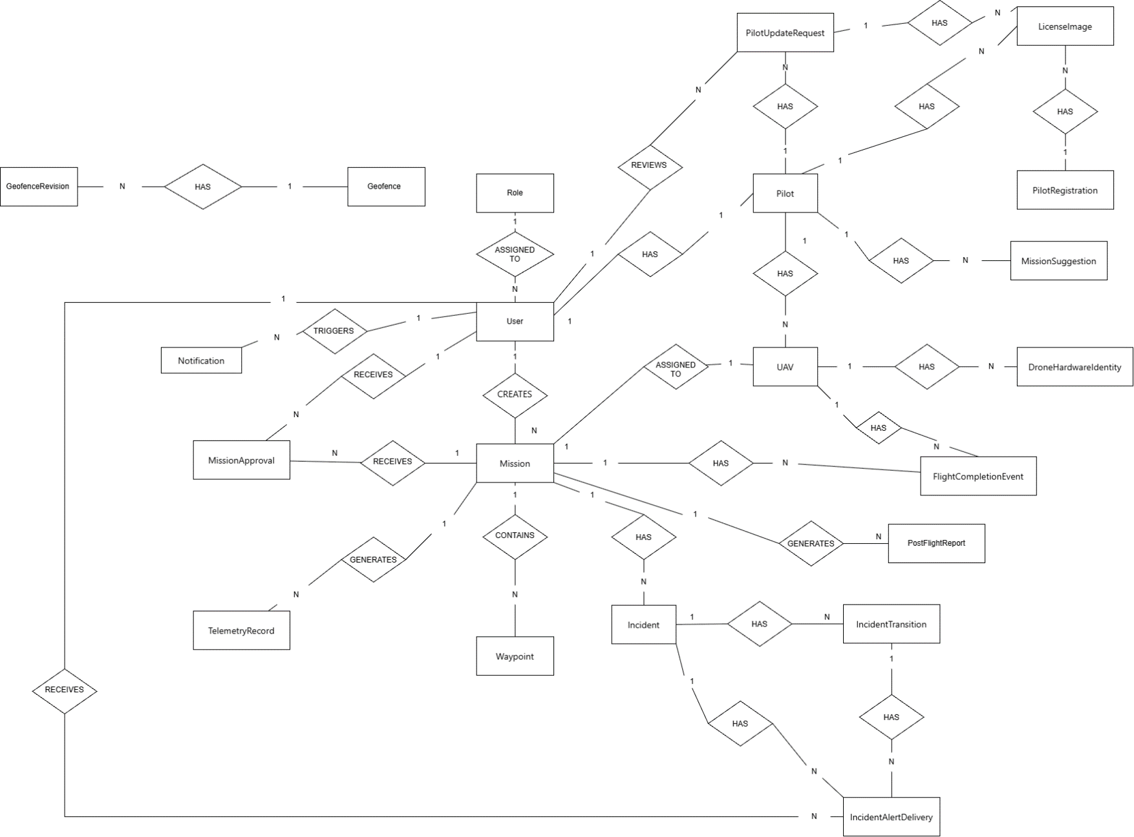
Figure 5. Entity Relationship Diagram.
Table Descriptions
No. | Entity | Domain | Description
1 | Role | Identity and access | Defines an authorization category assigned to user accounts and used to control access to system capabilities.
2 | User | Identity and access | Represents an authenticated system account and the actor behind mission, approval, review, and notification activities.
3 | Pilot | Identity and access | Stores the operational pilot profile associated with a user and links that profile to aircraft, evidence, requests, and suggestions.
4 | PilotRegistration | Identity and access | Represents a pilot onboarding or registration submission together with its supporting license evidence.
5 | PilotUpdateRequest | Identity and access | Captures a controlled request to update pilot information and supports review and attachment of evidence before changes are accepted.
6 | LicenseImage | Identity and access | Stores or references license-document imagery used as evidence for a pilot profile, registration, or profile update request.
7 | UAV | Fleet and airspace | Represents a pilot-registered aircraft managed by the platform, including its registering pilot, Manager-reviewed operational status, mission allocations, hardware identities and completion events. Managed fleet means registered platform records, not ownership by the platform.
8 | DroneHardwareIdentity | Fleet and airspace | Represents a hardware-level identity associated with a UAV, such as a serial, device, controller, or communication identity.
9 | Geofence | Fleet and airspace | Represents a logical operational or restricted area whose definition can evolve through versioned revisions.
10 | GeofenceRevision | Fleet and airspace | Represents one historical or current revision of a geofence, preserving changes to geometry or operational rules over time.
11 | Mission | Mission lifecycle | Acts as the central operational record for a planned flight and connects its creator, aircraft, route, approvals, telemetry, incidents, completion events, and reports.
12 | Waypoint | Mission lifecycle | Represents an ordered route point contained by a mission and used to define the intended flight path.
13 | MissionApproval | Mission lifecycle | Records an approval review received by a mission and associated with the user responsible for the review activity.
14 | MissionSuggestion | Mission lifecycle | Represents a mission-related recommendation or planning suggestion associated with a pilot.
15 | TelemetryRecord | Mission lifecycle | Represents telemetry generated during a mission, allowing operational and post-flight analysis of aircraft state.
16 | FlightCompletionEvent | Mission lifecycle | Records a completion-related lifecycle event connected to both the mission and the UAV that performed the flight.
17 | PostFlightReport | Mission lifecycle | Represents a report generated for a mission after flight activity, consolidating outcome and supporting evidence.
18 | Incident | Incidents and notifications | Represents an operational anomaly or safety event linked to a mission and its subsequent lifecycle and alert deliveries.
19 | IncidentTransition | Incidents and notifications | Records a change in an incident's lifecycle state so that status history and operational actions remain traceable.
20 | IncidentAlertDelivery | Incidents and notifications | Tracks delivery of an incident alert to a user, with context from the incident and its transition history.
21 | Notification | Incidents and notifications | Represents a user-facing system notification. The source diagram labels its relationship to User as TRIGGERS and should be reviewed for intended direction.
22 | MissionUpdateRequest | Mission review | Proposed plan and AutomaticFlightRequested payload; pending/decision scope and base/proposed hashes.
23 | MissionValidationRun | Mission review | Timestamped validation/preflight evidence, stage, current plan hash, result and source revisions.
24 | DroneConnection | Gateway authorization | Mission/UAV/owner/UID binding, lease expiry, revocation and latest heartbeat/sample times.
25 | TrustedGateway enrollment | Gateway authorization | Revocable gateway credential binding to UAV/controller UID; credentials are not browser plan data.
26 | MissionAutomationState | Flight automation | Consent actor/time, presence, planHash and connection binding, automation readiness/outcome.
27 | Dispatch command and outcome | Flight automation | Durable commandId, execution binding, compiled hash/profile, not-before/deadline, delivery and observed outcome; deduplicated.
28 | Flight execution evidence | Flight execution | Immutable approved snapshot, trusted start/landed/terminal evidence, partial outcome and post-flight linkage.

The approval transaction checks the mission, request identity, record scope and current validation evidence before applying the accepted metadata and ordered waypoints. It records the decision and closes the request in the same transaction. Any failure rolls back the complete operation. Rejection updates only the request and decision, preserving current mission content and prior approval. A stale or conflicting request returns 409. Notification delivery follows the committed decision.
Indexes support ordered mission waypoints, pending requests, latest mission telemetry, incident status and recipient alerts. Ingestion uses an idempotency key, while decisions use a unique request identity and terminal-state check. Backend authorization protects mission, history, media and streaming operations.

3. Detailed Design

3.1 Mission Planning and Approval
This feature covers mission submission, pre-flight validation, proposed updates and Manager decisions. Approval applies accepted content to the same mission; rejection preserves current content and any existing approval.

3.1.1 Class Diagram
The classes below separate mission editing, proposed content, review decisions and the approval transaction.
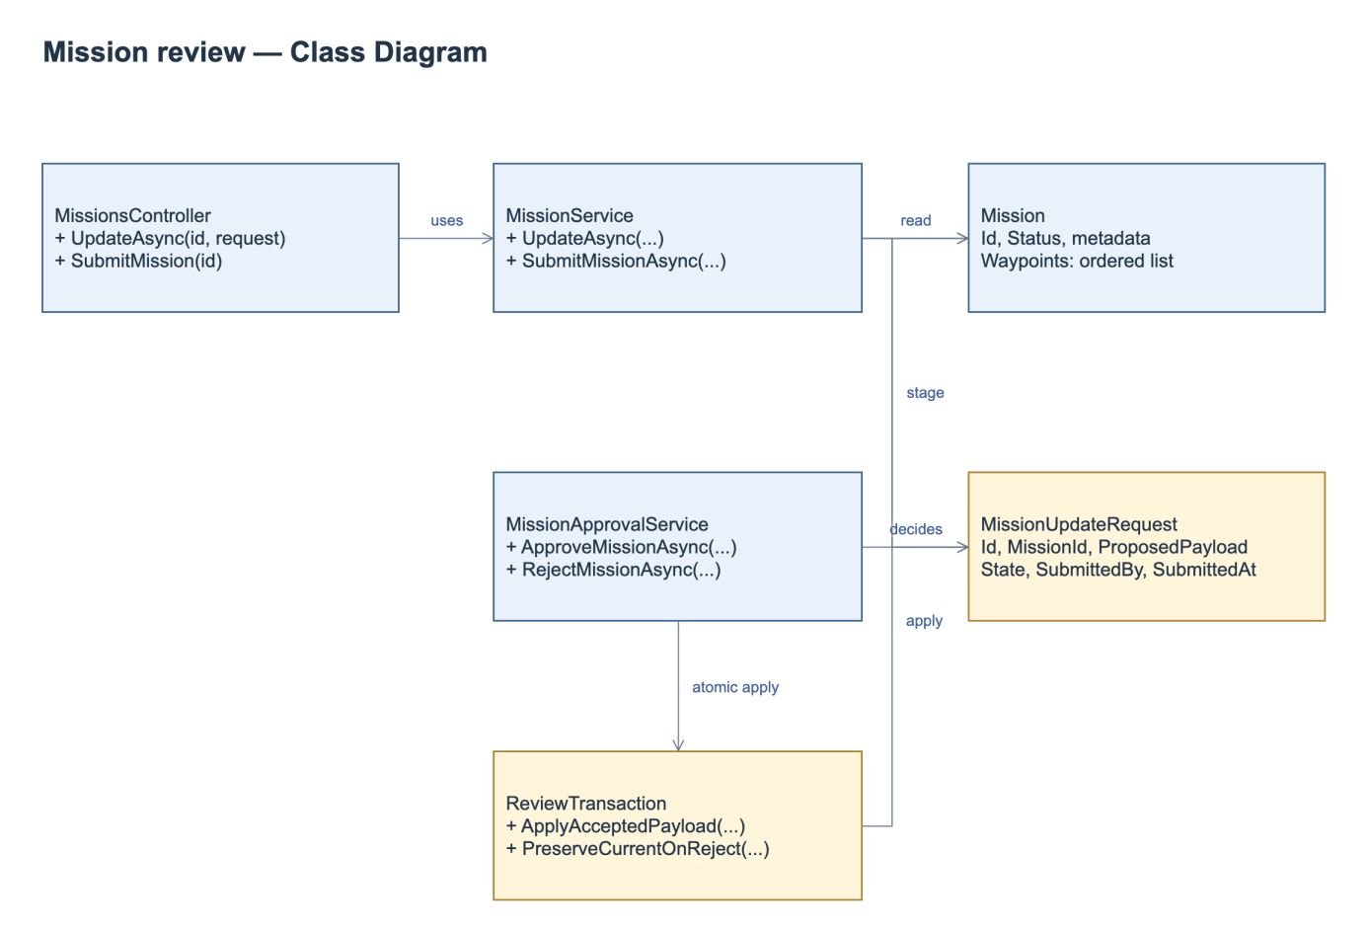
Figure 6. Mission Planning and Approval Class Diagram.
Class Specifications
No | Class / Operation | Specification
1 | MissionService.UpdateAsync | Input mission ID, authenticated operator and metadata/route. Authorize scope/state; reject malformed geometry; persist separate review request; run mandatory validation; return request ID/current mission summary. Accepted proposals are applied atomically; direct mutation of approved content is prohibited.
2 | MissionUpdateRequest | Owns proposed payload, author/time and review state, not a mission version. Current content remains outside payload and authoritative.
3 | MissionApprovalService | Approve/reject exact request, require current evidence; commit accepted data atomically or reject without content mutation. Repeated/stale decisions return current outcome or conflict.
4 | Review transaction / validation | One DB unit of work, request identity, input fingerprint and restriction revision. Concurrent edits cannot reuse validation or overwrite a newer accepted proposal.

3.1.2 Submit a Mission Update
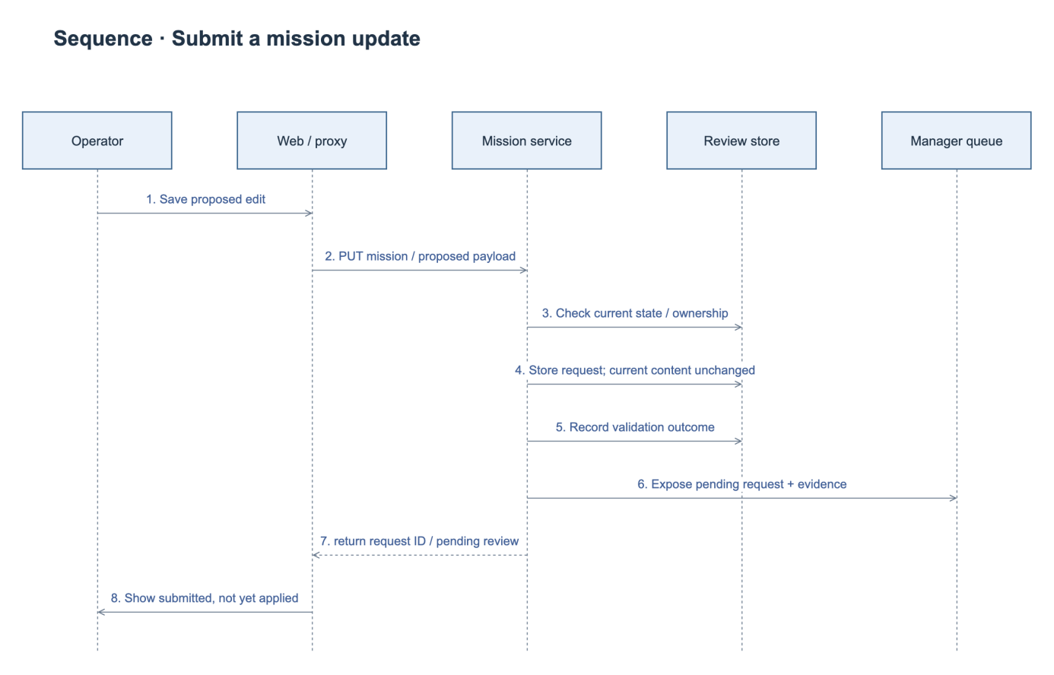
Figure 7. Submit Mission Update Sequence Diagram.

3.1.3 Approve a Mission Update
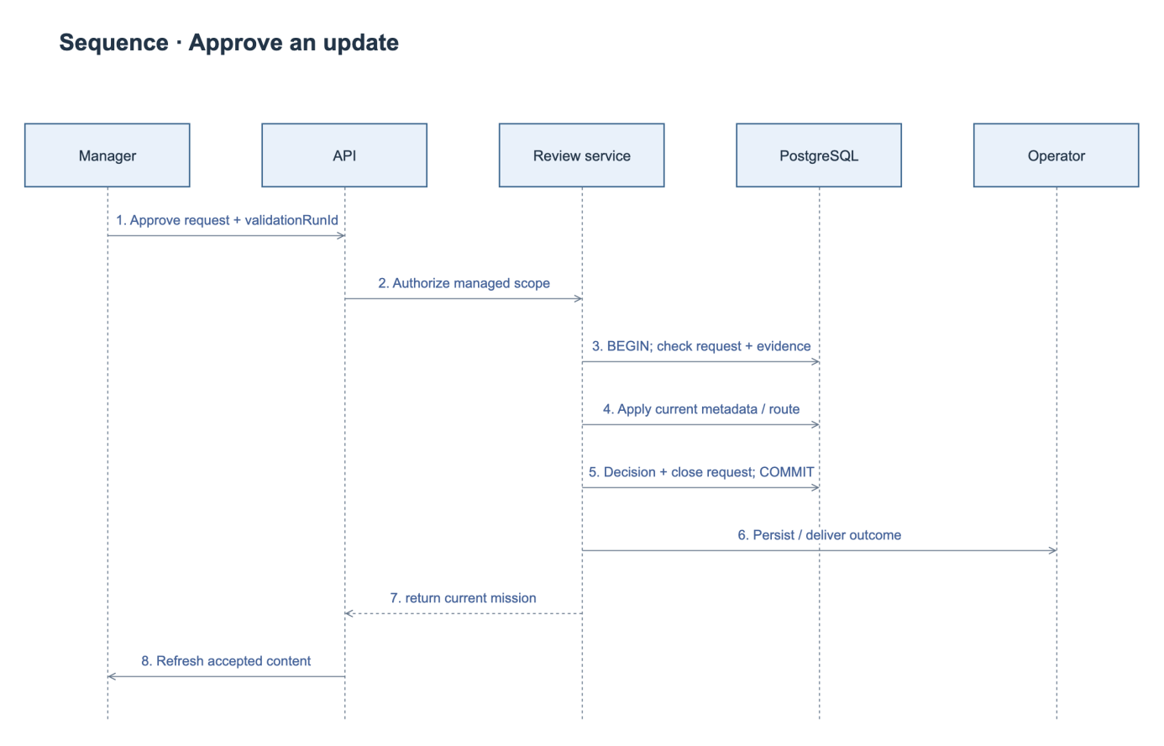
Figure 8. Approve Mission Update Sequence Diagram.

3.1.4 Reject a Mission Update
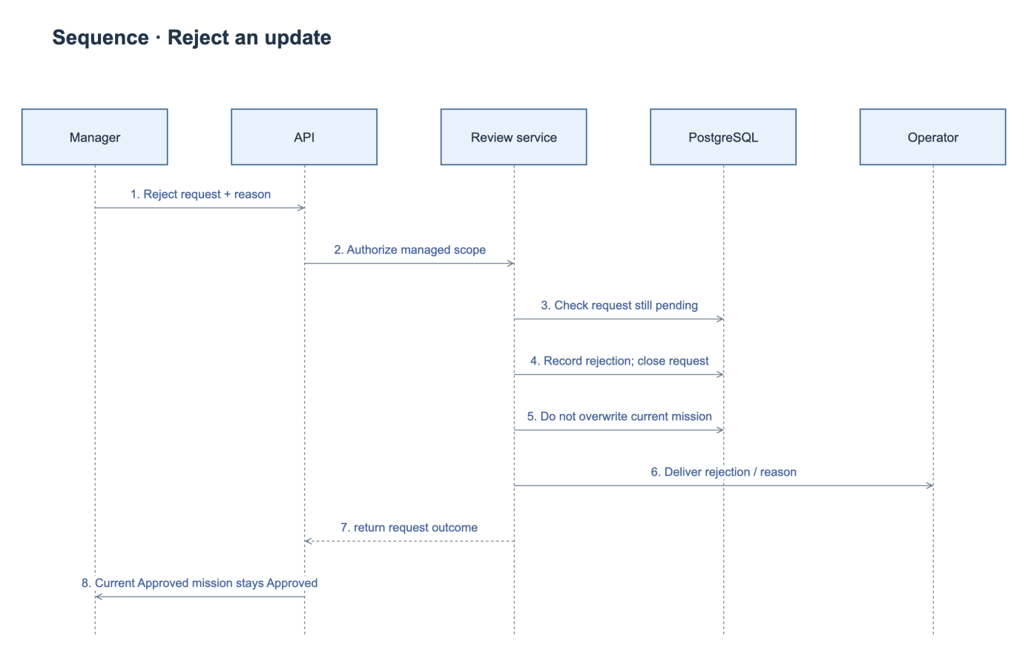
Figure 9. Reject Mission Update Sequence Diagram.
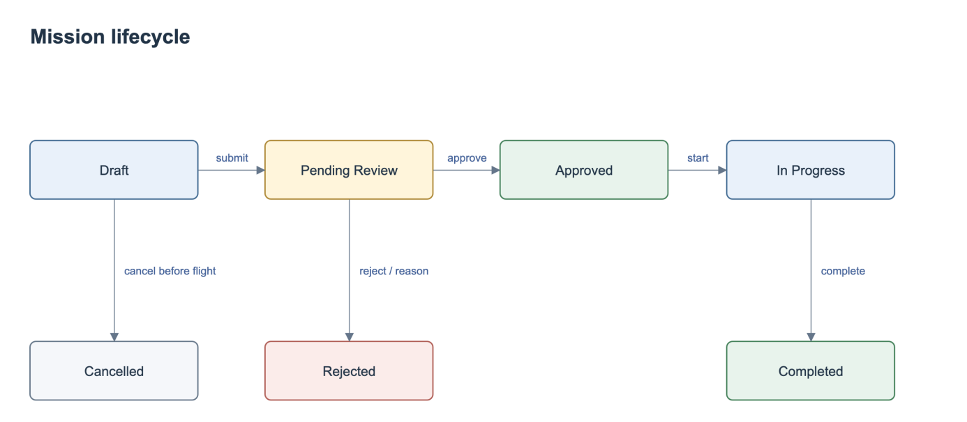
Figure 10. Mission State Diagram.
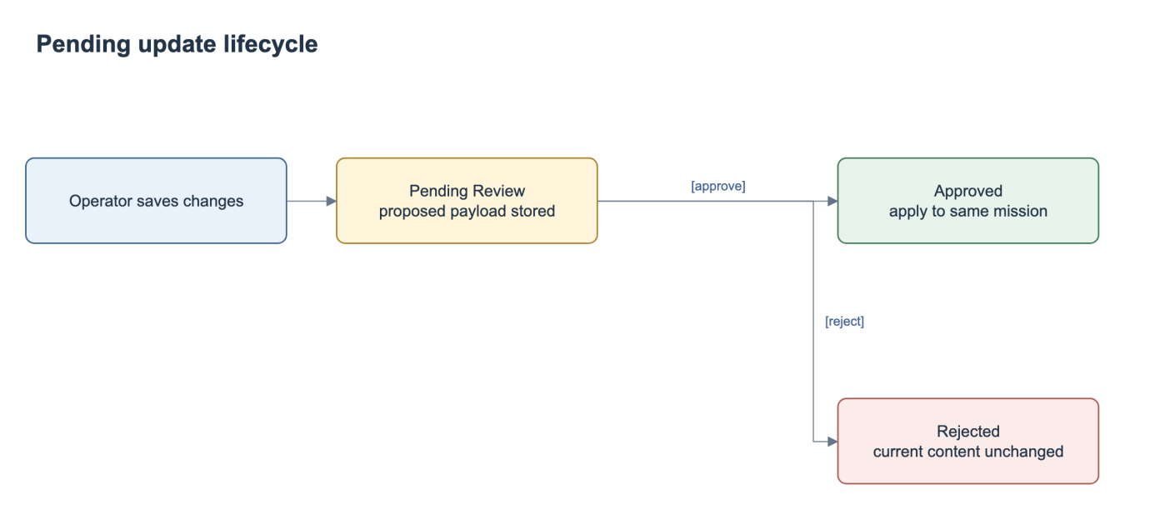
Figure 11. Mission Update Request State Diagram.
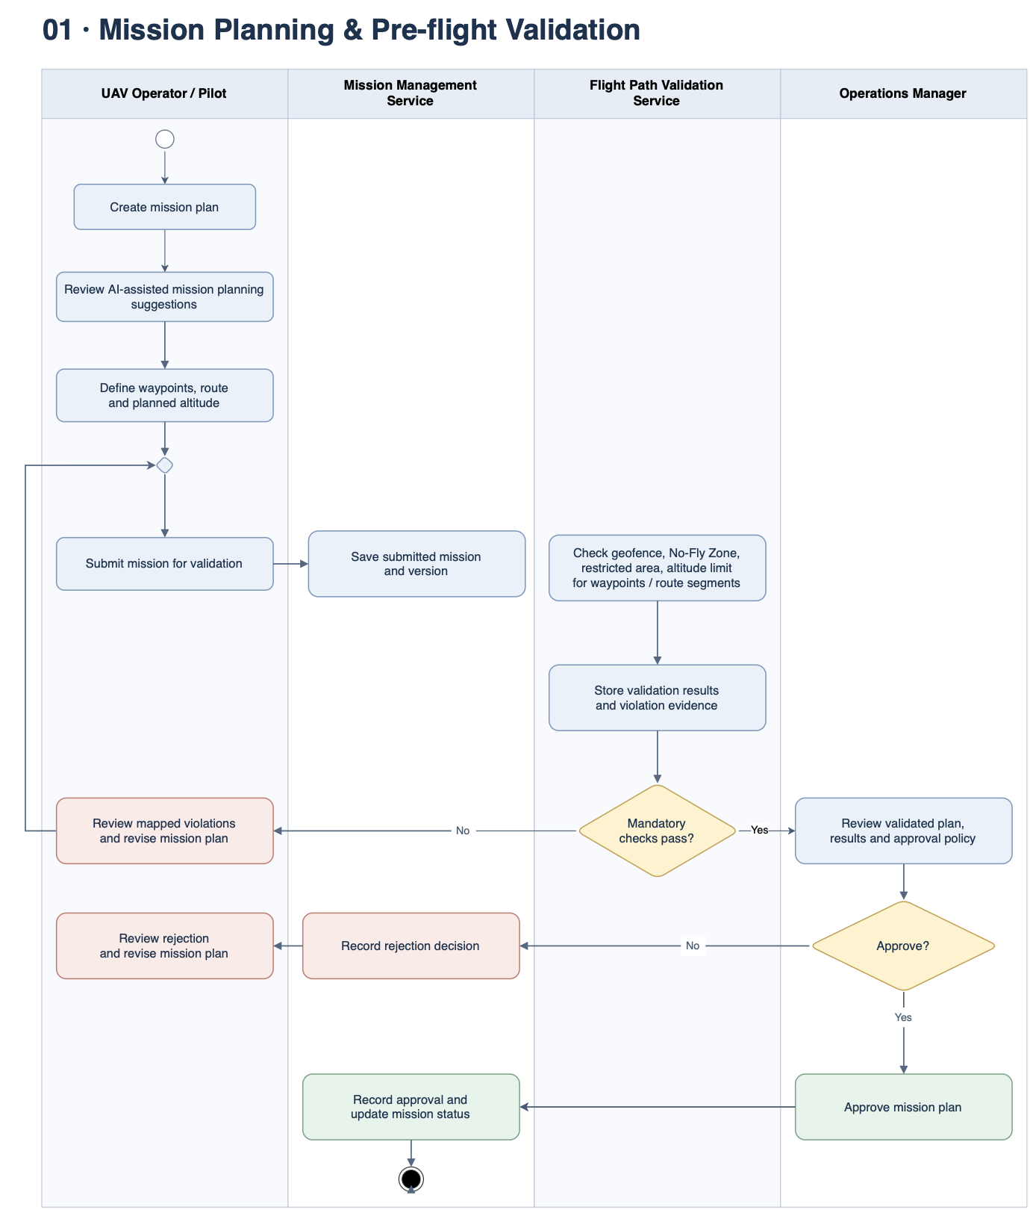
Figure 12. Mission Planning and Pre-flight Validation Workflow.

3.2 Realtime Monitoring and Incident Management
This feature receives timestamped telemetry, maintains the latest authorized mission state and records incident evidence and handling decisions.

3.2.1 Class Diagram
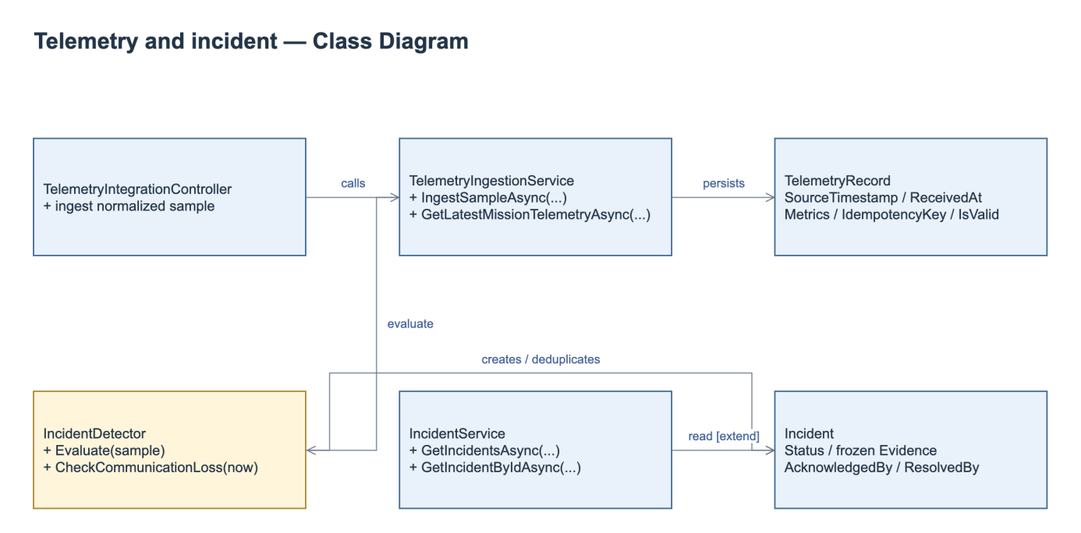
Figure 13. Telemetry and Incident Class Diagram.
Class Specifications
No | Class / Operation | Specification
1 | TelemetryIngestionService.IngestSampleAsync | Check integration authentication upstream, idempotency, UAV/mission association and source/received timestamps. Persist valid/invalid classification; avoid replacing latest by older out-of-order data.
2 | Latest / SSE | Authorize scope, send latest snapshot and incident feed; FE shows unavailable/null/stale. Current sequence IDs reset per connection; durable replay is not promised. Reconnect resynchronizes snapshot and alerts.
3 | IncidentDetector / timer | Evaluate battery, altitude and speed against configured unit-aware rules. An independent timer checks communication loss. Rule recovery conditions determine when a new abnormal episode may create another incident.
4 | Acknowledge / resolve | Enforce current state, actor and Manager-only resolution with reason; persist frozen source evidence and append-only timeline. Reject conflict, duplicate or out-of-scope mutation without changing evidence.

3.2.2 Ingest and Monitor Telemetry
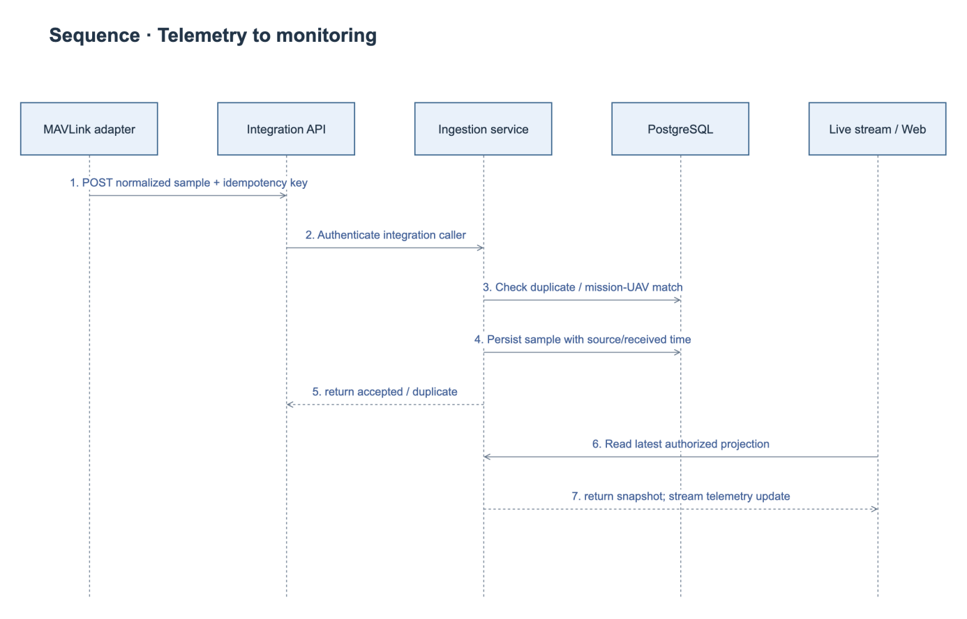
Figure 14. Telemetry Ingestion Sequence Diagram.

3.2.3 Acknowledge and Resolve an Incident
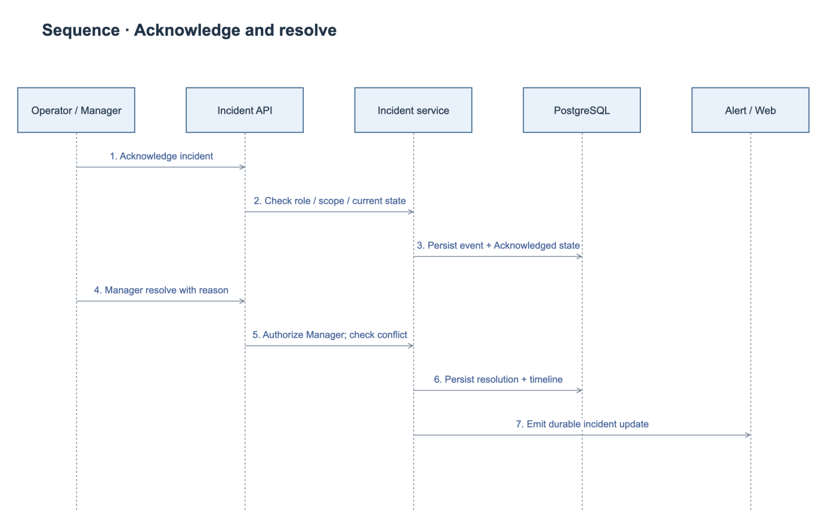
Figure 15. Incident Handling Sequence Diagram.
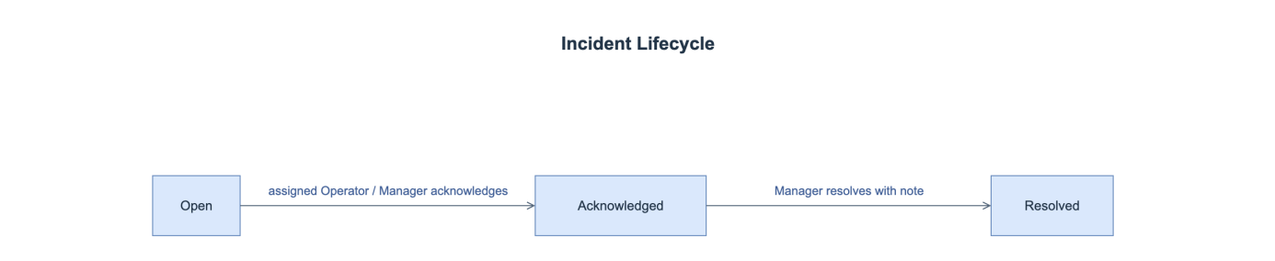
Figure 16. Incident State Diagram.

3.3 Post-flight History and Reporting
PostFlightService provides history queries, report generation, telemetry playback, mission incidents and operational analytics. Aggregation uses authorized persisted samples and UTC coverage windows. Missing metrics remain null. Mission completion follows the external execution event; it is not a browser flight-control command.

3.3.1 Class Diagram
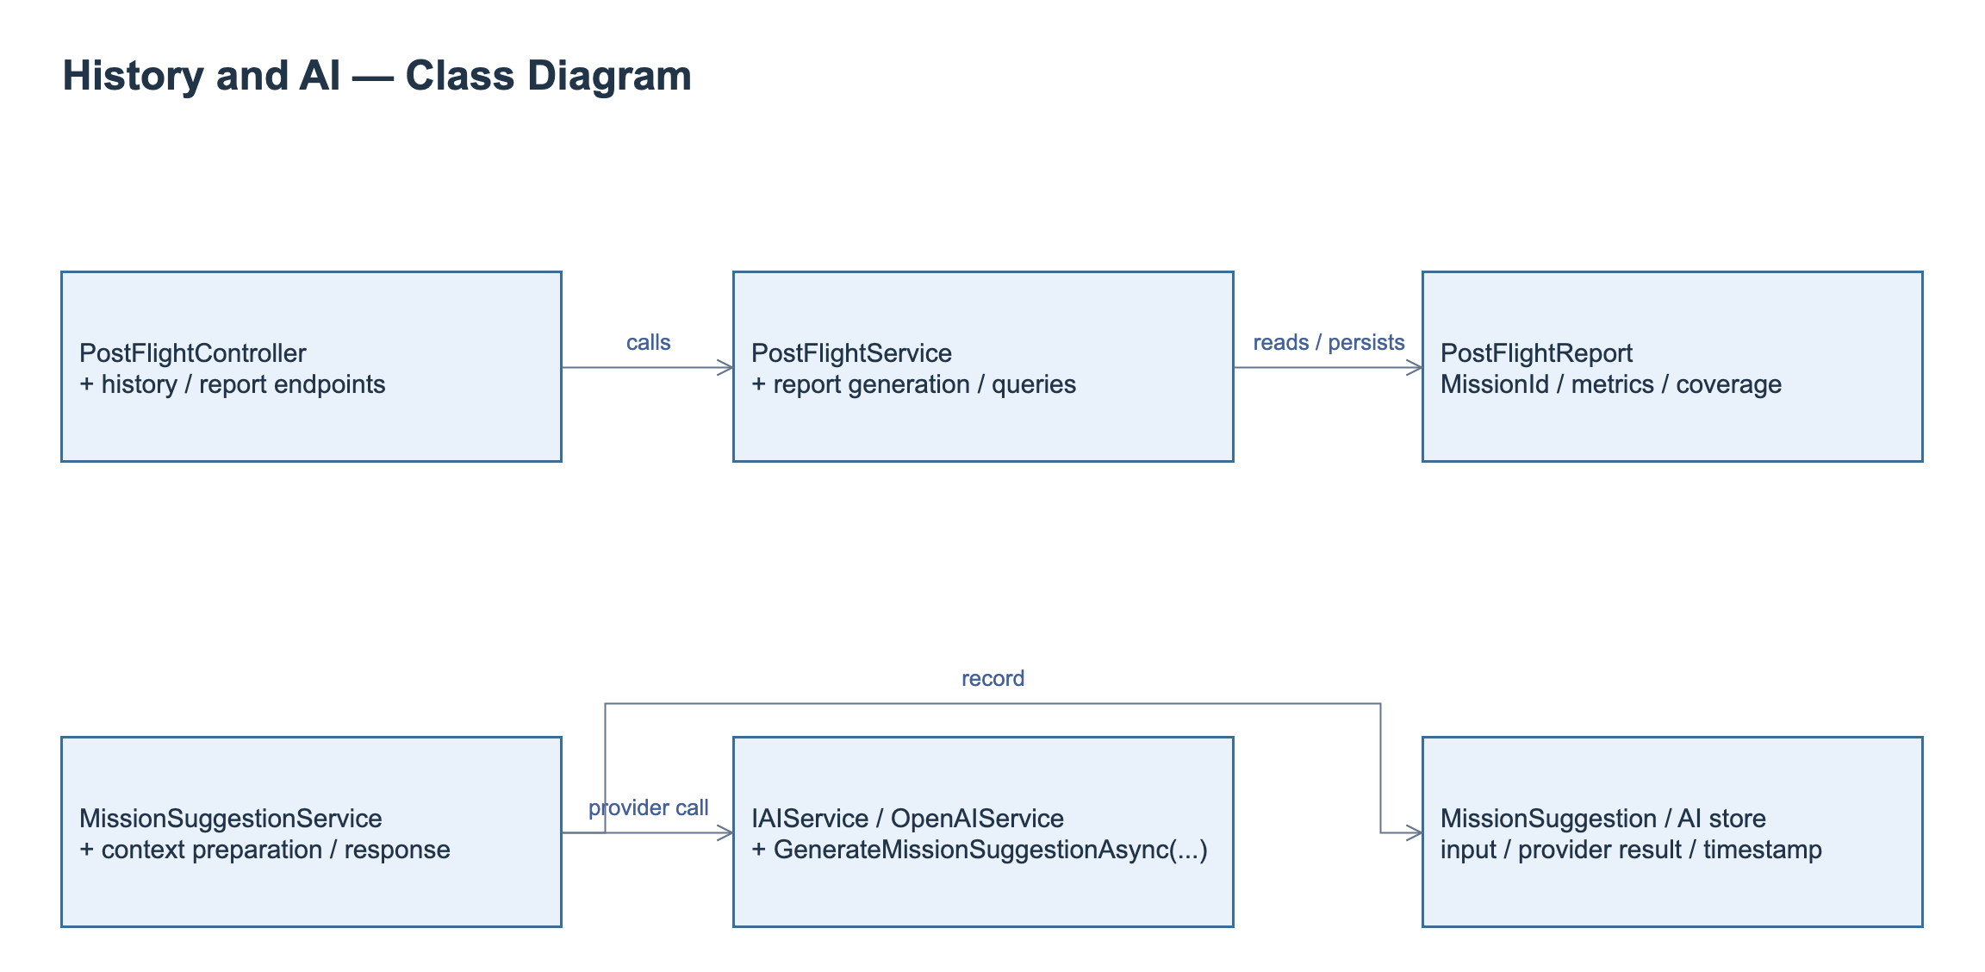
Figure 17. History, Reporting and AI Class Diagram.
Class Specifications
No | Class / Operation | Specification
1 | PostFlightService.GetFlightHistoryAsync | Queries scoped mission history with date, UAV and status filters and pagination.
2 | PostFlightService.GetReportByMissionIdAsync | Returns the persisted report, source mission, coverage and metrics; missing measurements remain unavailable.
3 | PostFlightService.GetTelemetryPlaybackAsync | Returns authorized ordered telemetry positions and timestamps for recorded-route playback.
4 | PostFlightService.FinalizeAndGenerateReportAsync | Processes the authorized completion context and aggregates persisted telemetry and incidents into the mission report.

3.3.2 Retrieve a Post-flight Report
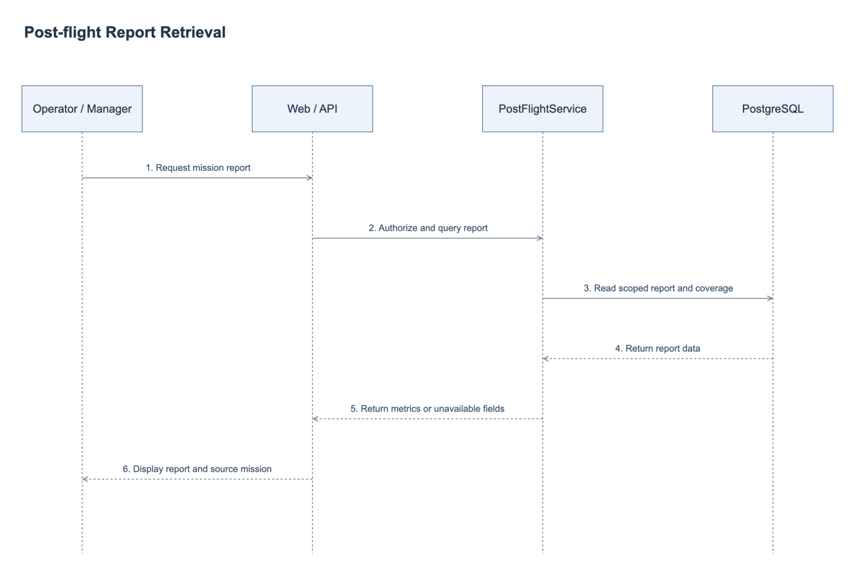
Figure 18. Post-flight Report Retrieval Sequence Diagram.

3.4 AI-assisted Mission Assessment
IAIService.GenerateMissionSuggestionAsync and OpenAIService provide the external AI adapter. MissionSuggestionService prepares and persists mission or update-request context, provider identity, timestamp and assessment outcome. Timeout, rate-limit and invalid-response handling return an unavailable result without changing mission approval. AI output remains advisory.

3.4.1 Class Diagram
The AI assessment classes and their relationships are included in Figure 18. Post-flight reporting and AI assessment share mission and operational evidence; their service responsibilities are specified separately below.
Class Specifications
No | Class / Operation | Specification
1 | MissionSuggestionService | Authorizes and prepares mission or update context, calls the configured adapter and persists the assessment outcome.
2 | IAIService.GenerateMissionSuggestionAsync | Defines the provider contract for an advisory mission assessment.
3 | OpenAIService | Sends bounded authorized context and handles provider timeout, rate limit and invalid responses.

3.4.2 Request an AI Assessment
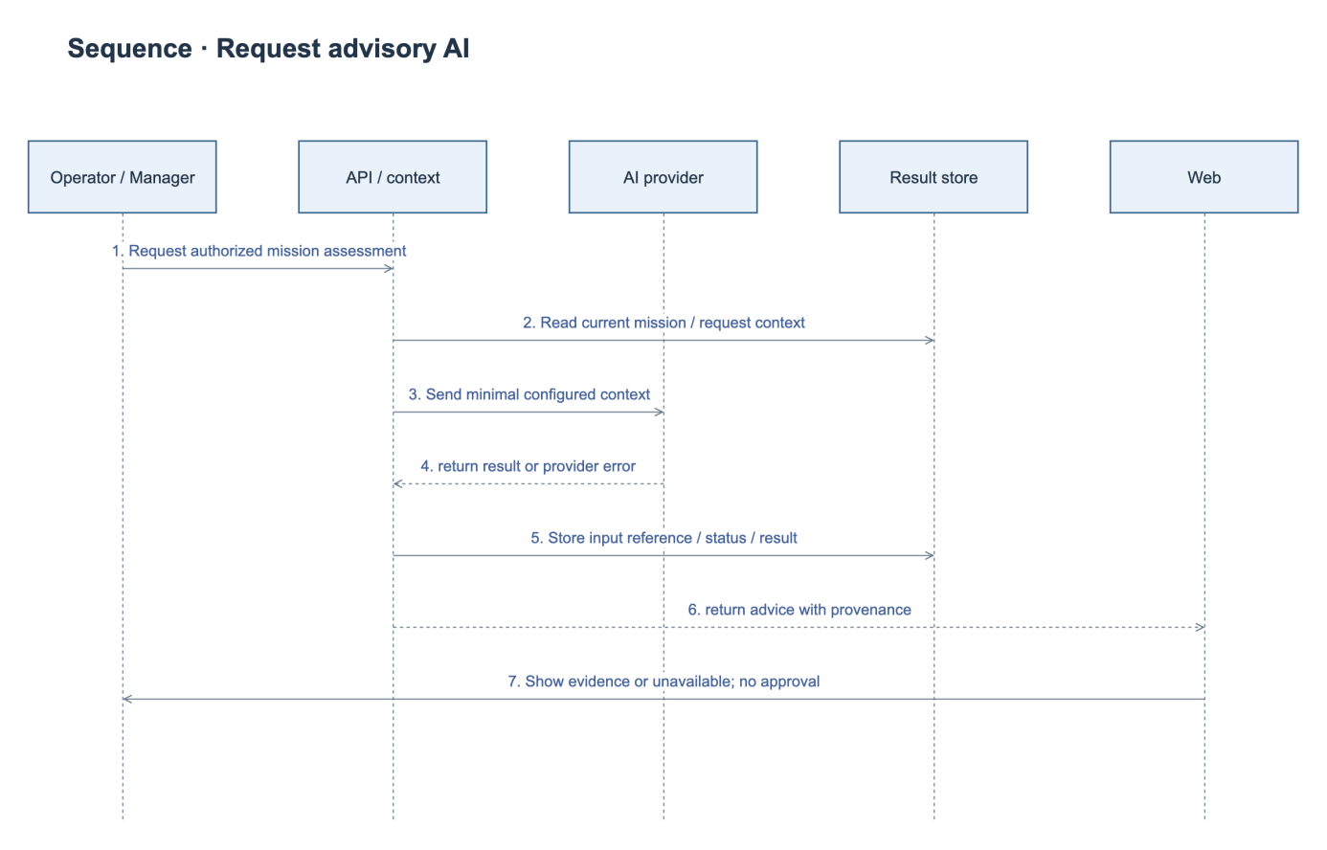
Figure 19. AI Assessment Sequence Diagram.

3.5 Automatic Flight Execution
Final functional specification
MF1 / WF-01: NghiaHQ — planning and preflight. MF2 / WF-02: ThongLQ — gateway, scheduled automatic execution, realtime monitoring and incidents. MF3 / WF-03: DucDDA — post-flight history/reporting. MF4 / WF-04: KhanhGNG — AI assessment. ThongLQ remains team leader and dossier coordinator.

Scope and operating boundary
The final functional baseline covers scheduled automatic mission execution for supported ArduPilot Copter and PX4 multicopter profiles through the trusted gateway on Jetson or a radio-connected laptop. The platform manages approval, mission compilation/upload/read-back, explicit pilot consent, scheduled dispatch, execution evidence and post-flight records. The autopilot retains stabilization, navigation loops, pre-arm checks and onboard failsafes. AI remains advisory and cannot authorize approval or launch.

End to end operation
The operator enables AutomaticFlightRequested in the reviewed plan. After approval, the gateway verifies the bound controller UID and firmware profile, compiles the approved route, uploads it and verifies the normalized read-back. In [T−5 minutes, scheduled start), the authenticated pilot confirms the exact plan and connection while the portal is visible and online. At the scheduled start the scheduler revalidates all conditions, issues a uniquely identified, expiring execution envelope, and records gateway outcomes. Mission InProgress is recorded only after observed flight-state evidence; accepted upload or command ACK alone is insufficient. Trusted landed/completion evidence finalizes the flight and report.

Dispatch authorization
All dispatch prerequisites are conjunctive: approved opted-in mission; no pending update; eligible pilot/UAV and reserved schedule; identical planHash, compiledMissionHash, controller UID and connection/lease; verified firmware capabilities and mission read-back; pilot confirmation in the permitted window; presence and gateway heartbeat no older than 30 seconds; telemetry no older than 15 seconds; a fresh passing preflight for the current plan within 60 seconds; and successful local pre-arm checks. Presence is refreshed every 10 seconds. A changed plan, controller, connection or uploaded mission invalidates previous consent and execution authorization.

Exceptions and pilot authority
A blocked prerequisite, expired envelope or cancelled consent prevents dispatch and produces a specific reason. Reconnection or restart never creates late launch consent. Delivery retries reuse the same commandId and cannot create another start. If aircraft outcome is uncertain, the gateway reconciles observed state and does not blindly repeat arm/start. After takeoff, loss of web/backend connectivity follows the configured onboard failsafe; pilot RC takeover remains available. A preflight Cancel action cannot stop an airborne vehicle or erase its execution evidence.

Backend and portal responsibilities
MissionAutomationController and MissionAutomationService expose due/read/presence/confirm/cancel/plan contracts. An AutomationScheduler role creates one dispatch per immutable approved execution after a transactional gate recheck. The portal displays preparation, upload/read-back, gate reasons and observed execution separately; it never issues an autopilot command directly.

Gateway and adapter responsibilities
A MissionCompiler selects a versioned ArduPilot/PX4 multicopter profile. A MissionTransfer role handles upload/read-back normalization. An ExecutionAdapter role validates and durably deduplicates the expiring command envelope, checks local pre-arm/UID/hash state and applies the supported mode/arm/start sequence. Gateway roles may share a deployable Python process; the boundaries are responsibility contracts rather than a requirement for separate services.

Execution envelope and persistence
The versioned envelope contains commandId, missionId, uavId, ownerId, controllerUid, connectionId/lease identity, planHash, compiledMissionHash, adapter/profile version, scheduledAtUtc, issuedAtUtc and expiresAtUtc. MissionAutomationState stores presence/consent binding; dispatch and outcome records retain durable identity and reasons. Flight execution stores an immutable approved snapshot. Unique dispatch identity and commandId constraints prevent concurrent/replayed starts.

Automation state and mission lifecycle
Automation states are Disabled, AwaitingApproval, Preparing, AwaitingConsent, Ready, Dispatching, Executing, Completed, Blocked, Failed, Cancelled or Expired. These describe automation outcomes separately from the mission lifecycle. Approval/confirmation/upload do not change the mission to InProgress; observed trusted flight does. A completion event records outcome before idempotent report generation.

Transaction and failure boundaries
Validate approval/pending-request pointer, schedule reservation, current hashes, connection and consent in the same dispatch transaction. Commit command identity/outbox before transmission. The gateway persists receipt before side effects and uses durable outcome reconciliation on restart. Publish ACK/state changes after commit; retry notification delivery independently of flight execution.

Interfaces and synchronization
Human requests use role/record authorization; gateway traffic uses trusted enrollment and a current mission lease over HTTPS/WSS. The plan endpoint returns the owner-scoped contract; gateway command/status messages carry envelope identity and evidence. Control transport, telemetry projection and SSE display are separate paths. Local autopilot loops do not depend on browser polling.

Protocol and profile references
Protocol references: MAVLink Mission Protocol, ArduPilot AUTO and PX4 Mission. Store firmware/profile versions; ACK alone is not flight evidence. Official links appear in the operating guide.

